**PYTHON PATROL**

# Vision Statement

The goal of our Team is to have each member learn the skills necessary to create a computer simulation using the appropriate models and techniques.

During this journey, we know each member will gain experience in collaborative software development. This includes concepts such as:

* Git and basic code integration
* Teamwork and communication
* Software design and diagrams

The course material should challenge the team but also sharpen each member’s current skill set. However, more importantly each member is responsible for helping each other team member. This would imply teaching concepts from disciplines other members might not be familiar with or just being patient when explaining an idea to another member.

By applying the team’s current skills, a desire for knowledge and a strong work ethic, we believe we can produce meaningful high quality work.

# Artifact Description

Not everyone on the team has experience with github, so we’ve decided to undergo a few basic starter tutorials to attempt to bring everyone up to speed. The tutorials that our team will be completing can be found at

I was thinking we could just all go through a bitbucket tutorial

This way we can learn some git and drop something in the repo as proof

# Team Interaction Rules

All team members will agree to the following regulations for all in-person and digital forms of communication:

1. Give every team member a fair hearing without judgement

2. Equal participation is mandatory except under reasonable circumstances and with prior notice

3. Be respectful and considerate of your verbal and body language

4. Process for decision-making:

a. Pitch ideas

b. Discuss and provide feedback on ideas

c. Rank ideas based on popular opinion

d. Attempt most popular idea

5. Each member has a chance to express their opinion on every subject of discussion

6. Contact a team member(s) in advance for absence

7. No decision will be made until every team member has expressed their acceptance of an idea

# 

# Team Signatures

X_________C.A._____________________________ Cole Amaratunge

X  Kris Kwon

X 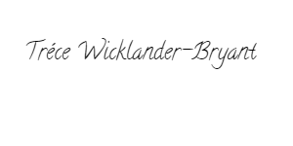 Trece Wicklander-Bryant

X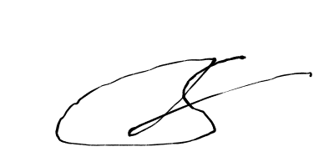 Sam Qian